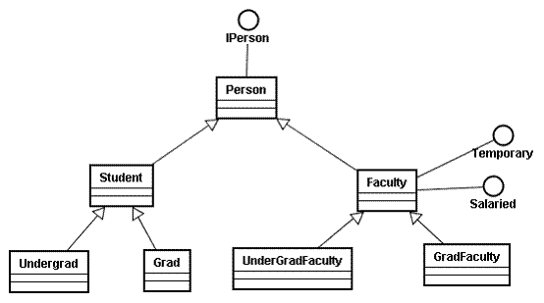

Develop a hierarchy of the department of a college.
Use Interfaces, Abstract classes and Concrete classes wherever applicable.

Person is the superclass for all the people , while Student and Faculty are the subclasses of Person. Person can implement an IPerson interface .
A Faculty is a Salaried type (Interface) .

A Student class will be extended by Undergrad or Graduate subclass. Similarly Faculty can be of UnderGrad or GradType . Faculty may also be of Temporary type (Interface).

Abc Shop Inventory Management

Abc shop deals with trading of various products. Every product has product id, product name and serial number. Some products like Microsoft Office , Tally etc. has different system requirements like OS, Memory and also needs license key. Shop also deals with products like Computers, Laptops, Car-Deck, Home Theater systems which has different dimensions, capacity, brand, power supply requirements, battery backup, etc. Develop hierarchy of various products Abstract classes, Concrete classes and Interfaces as applicable.

(Note : Use appropriate additional fields wherever required.)

Implement this hierarchy using Java and Print Information of all products with the help of Array.

